NAME : S SURENDER

REG NO:1924260070
Set 18: Product Inventory Management
Data Visualization using R

Aim
To analyse product inventory using a bar chart, a stacked bar chart, a table and a dashboard in R.

Procedure
- Open RStudio and load the packages ggplot2 and gridExtra (install them once with install.packages(c("ggplot2", "gridExtra"))).
- Create the inventory data as a data frame. The data has no category column, so categories are assumed.
- Question 1: draw the bar chart of quantity with geom_col().
- Question 2: draw the stacked bar chart of quantity by category with geom_col().
- Question 3: make the table with tableGrob().
- Question 4: join the charts and the table into a dashboard with arrangeGrob().
- Run the code and note the output and the figures.

R Code
library(ggplot2); library(gridExtra)

# Dataset (Category is assumed, as the data has no category column)
inv <- data.frame(Product_ID = 1:3, Product = c("Product A","Product B","Product C"), Quantity = c(250, 175, 300), Price = c(20, 15, 18),
Category = c("Category 1","Category 2","Category 1"))
print(inv)
print(aggregate(Quantity ~ Category, inv, sum))

# 1. Bar chart - quantity of each product
p1 <- ggplot(inv, aes(Product, Quantity)) + geom_col(fill = "steelblue") + geom_text(aes(label = Quantity), vjust = -0.5) +
labs(title = "Quantity of Each Product", x = "Product", y = "Quantity Available")

# 2. Stacked bar chart - products within categories
p2 <- ggplot(inv, aes(Category, Quantity, fill = Product)) + geom_col() + labs(title = "Quantity by Category", x = "Category", y = "Quantity")

# 3. Table
tb <- tableGrob(inv[, 1:4], rows = NULL)

# 4. Dashboard
dash <- arrangeGrob(p1, p2, tb, layout_matrix = rbind(c(1,2), c(3,3)), top = "Inventory Dashboard")

ggsave("set18_q1.png", p1, width = 6, height = 4, bg = "white") ggsave("set18_q2.png", p2, width = 6, height = 4, bg = "white")
ggsave("set18_q3.png", arrangeGrob(tb, top = "Product Inventory Table"), width = 5, height = 2, bg = "white") ggsave("set18_q4.png", dash, width = 12, height = 8, bg = "white")

Output
1
2
Product_ID Product Quantity Price Category 1 Product A 250 20 Category 1
2 Product B
175 15 Category 2

3 3 Product C 300 18 Category 1 Category Quantity
1 Category 1 550
2 Category 2 175
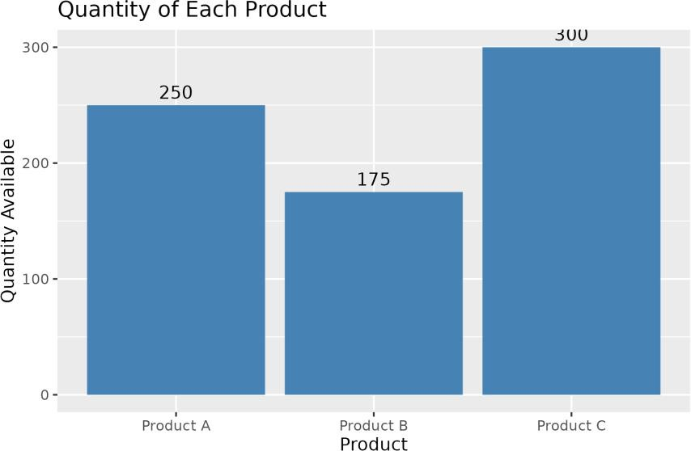

Figure 18.1: Q1 - Quantity of each product
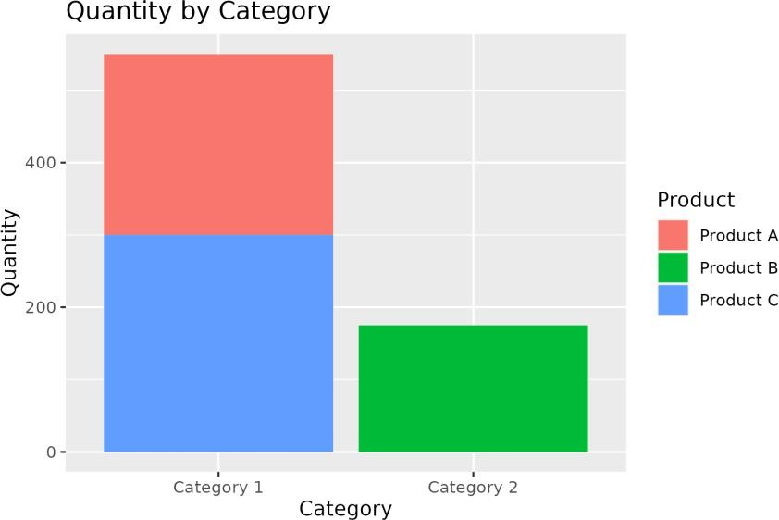

Figure 18.2: Q2 - Stacked bar chart by category (assumed)
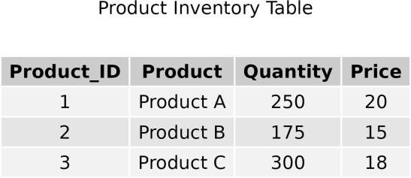

Figure 18.3: Q3 - Inventory table

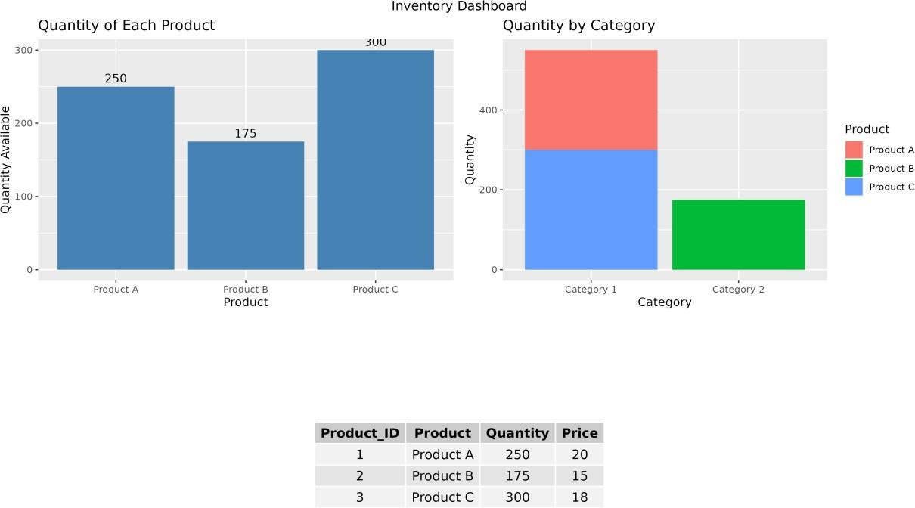

Figure 18.4: Q4 - Dashboard

Result
  - Product C has the most stock (300) and Product B the least (175).
  - Total stock is 725 units.
  - Categories are assumed, so the stacked chart is for demonstration.

